
APEX ACADEMIC CENTRE www.apexacademiccentre.co.za

NATIONAL SENIOR CERTIFICATE

GRADE 12

GEOGRAPHY P1

NOVEMBER 2023

MARKS: 150

TIME: 3 hours

This question paper consists of 19 pages.

INSTRUCTIONS AND INFORMATION

1.  2.  3.  4.  5.  6.  7.  8.  9.  10.  11.  12.  13. | This question paper consists of TWO sections.  SECTION A  QUESTION 1: CLIMATE AND WEATHER (60)  QUESTION 2: GEOMORPHOLOGY (60)  SECTION B  QUESTION 3: GEOGRAPHICAL SKILLS AND TECHNIQUES (30)  Answer ALL THREE questions.  ALL diagrams are included in the QUESTION PAPER.  Leave a line between the subsections of questions answered. Start EACH question at the top of a NEW page.  Number the answers correctly according to the numbering system used in this question paper.  Do NOT write in the margins of the ANSWER BOOK. Draw fully labelled diagrams when instructed to do so.  Answer in FULL SENTENCES, except when you have to state, name, identify or list.  Units of measurement MUST be indicated in your final answer, e.g. 1020 hPa, 14 °C and 45 m.  You may use a non-programmable calculator. You may use a magnifying glass.  Write neatly and legibly.

SPECIFIC INSTRUCTIONS AND INFORMATION FOR SECTION B

14.  15.  16.  17. | A 1 : 50 000 topographical map 3126DD QUEENSTOWN and a 1 : 10 000 orthophoto map 3126 DD 1 NOOITGEDACHT are provided.  The area demarcated in RED/BLACK on the topographical map represents the area covered by the orthophoto map.  Show ALL calculations. Marks will be allocated for steps in calculations.  You must hand in the topographical and orthophoto map to the invigilator at the end of this examination.

SECTION A: CLIMATE AND WEATHER AND GEOMORPHOLOGY QUESTION 1: CLIMATE AND WEATHER
1.1 | Refer to the sketch below of a synoptic weather map. Complete the statements in COLUMN A with the options in COLUMN B (page 4). Write only  Y or Z next to the question numbers (1.1.1 to 1.1.7) in the ANSWER BOOK,  e.g. 1.1.8 Y.
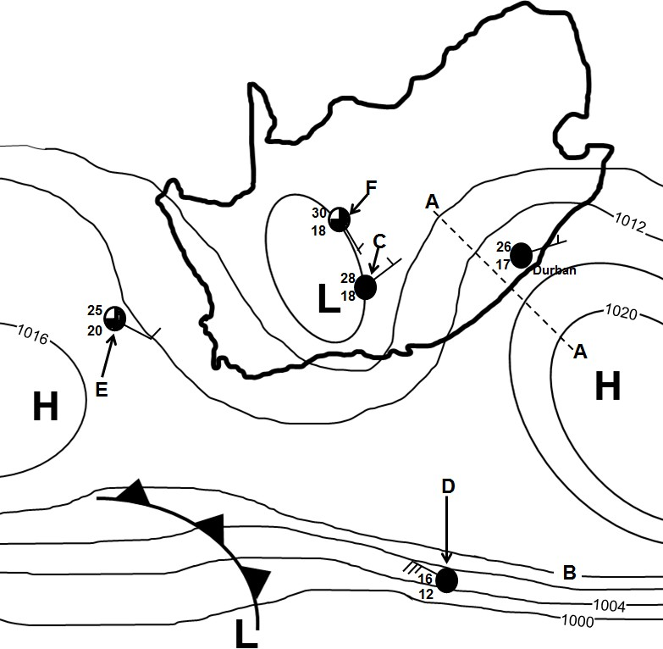
[Source: Examiner's own sketch]

COLUMN A |  | COLUMN B
1.1.1 | The synoptic weather map illustrates typical  … conditions. | Y Z | winter summer
1.1.2 | Line A-A represents a … | Y  Z | ridge  trough
1.1.3 | The air pressure reading of isobar B  is … hPa. | Y Z | 1012  1016
1.1.4 | The air pressure gradient is steeper around  the weather station at … | Y  Z | D  E
1.1.5 | The north-easterly wind at Durban is influenced by the … circulation of air. | Y Z | anticlockwise clockwise
1.1.6 | The unstable weather conditions at weather station C are due to the development of a …  front. | Y Z | cold moisture
1.1.7 | Which weather station illustrates the following weather changes at F in the next 24 hours?  - The wind direction changes to south-west.  - The air temperature decreases by 6 °C. | Y  Z | 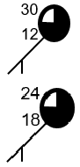
(7 x 1) (7)
  - Various options are provided as possible answers to the following questions. Choose the answer and write only the letter (A–D) next to the question numbers (1.2.1 to 1.2.8) in the ANSWER BOOK, e.g. 1.2.9 D.

Refer to the sketch below showing valleys in the Southern Hemisphere to answer QUESTIONS 1.2.1 to 1.2.4.
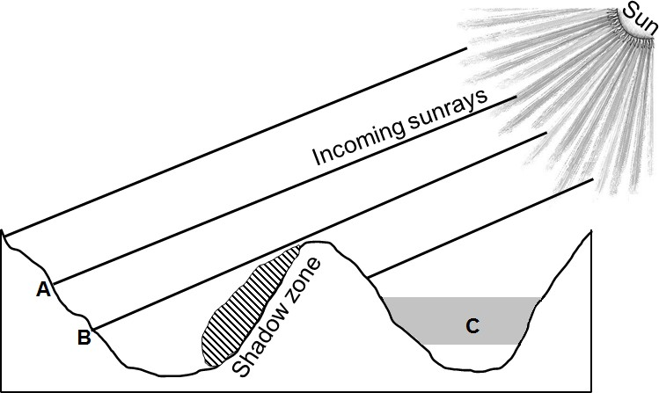
[Source: Examiner's own sketch]

1.2.1 | The relationship between slopes and the sun's rays is referred to as …
 | A | insolation.
 | B | aspect.
 | C | north-facing slope.
 | D | terrestrial radiation.
1.2.2 | The surface from A to B is intensely heated because it is …
 | A | receiving oblique sunrays.
 | B | at a lower latitude.
 | C | receiving direct sunrays.
 | D | at a higher altitude.
1.2.3 | The climatological phenomenon occurring at C is …
 | A | radiation fog.
 | B | advection fog.
 | C | terrestrial radiation.
 | D | a frost pocket.
1.2.4 | Dense vegetation is found in the shadow zone due to … conditions.
 | A | warm
 | B | dry
 | C | moist
 | D | windy
Refer to the sketch below depicting rural and urban climates to answer QUESTIONS 1.2.5 to 1.2.8.

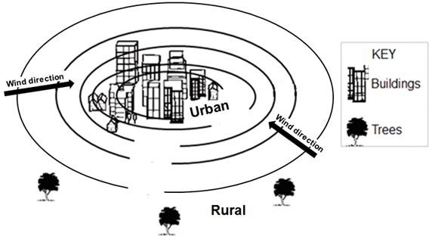
[Adapted from https://www.researchgate.net]

    - Which graph below represents the change in temperature from the rural area to the urban area?

A  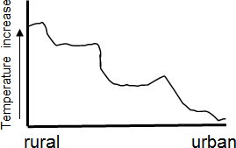 | B  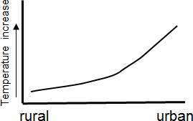
C  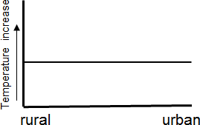 | D  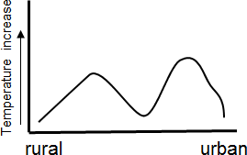
[Source: Examiner's own sketch]

    - The reason for the change in temperature (answer to QUESTION 1.2.5) is due to … surfaces and … storm-water systems in urban areas.

      - natural
      - artificial
      - more
      - less

        - (i) and (iii)
        - (i) and (iv)
        - (ii) and (iii)
        - (ii) and (iv)

    - The wind direction from the rural area to the urban area is influenced by … temperatures and … air pressure in urban areas.

      - warmer
      - cooler
      - higher
      - lower

        - (i) and (iii)
        - (i) and (iv)
        - (ii) and (iii)
        - (ii) and (iv)

    - The urban area will experience … cloud cover with a/an … in precipitation than the rural area.
- more; increase
- less; decrease
- more; decrease
- less; increase (8 x 1) (8)

  - Refer to the infographic below on mid-latitude cyclones.

WARNING OF SEVERE WEATHER CONDITIONS OVER WESTERN CAPE  A well-developed cold front of a mid- latitude cyclone reached the Western Cape on Thursday morning. It brought rainfall which spread to the south- western parts of the Western Cape (Cape Town, Cape Agulhas) and reached the south-eastern parts late afternoon. The bulk of the rain fell over the south-eastern parts (Mossel Bay, Knysna) of the south coast from the afternoon into Friday morning, where rainfall increased over 36 hours.  [Adapted from www.weathersa.co.za/home/warnings] | MAP SHOWING THE AFFECTED AREA  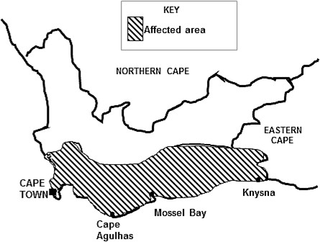  [Adapted from www.weathersa.co.za/home/warnings]
GRAPH SHOWING AVERAGE RAINFALL  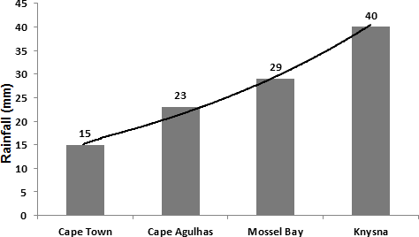 | CROSS-SECTION OF COLD FRONT  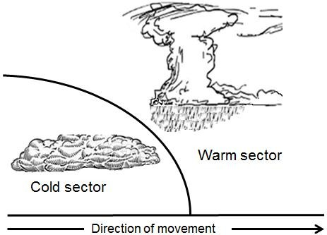
[Source: Examiner's own sketches]

1.3.1 The mid-latitude cyclone mentioned in the extract  (initial/mature) stage. |  | is | in the  (1 x 1) | (1)
1.3.2 Give a reason for your answer to QUESTION 1.3.1. | (1 x 2) |  |  | (2)
1.3.3 Why did the rainfall mentioned in the extract Cape Town to Mossel Bay and Knysna? | spread from  (1 x 2) |  |  | (2)

    - Refer to the graph and determine the lowest and highest rainfall, in millimetres, recorded in the Western Cape over 36 hours. (2 x 1) (2)

    - With reference to the cross-section, explain how a well-developed
cold front results in heavy rainfall over the Western Cape. (2 x 2) (4)

    - How will the heavy rainfall negatively affect the physical (natural) environment in and around the Western Cape? (2 x 2) (4)
  - Refer to the satellite image of a tropical cyclone in the mature stage below.
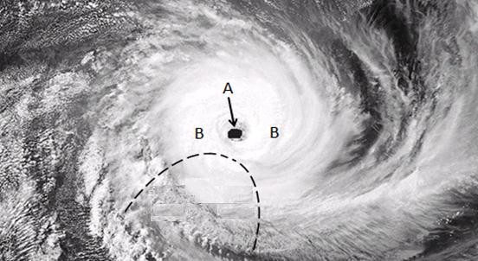

Forward (Leading) left-hand quadrant
[Adapted from https://www.google.com/url?sa=i&url=https%3A%2F]

    - State ONE condition required for the development of the tropical cyclone. (1 x 1) (1)

    - In which hemisphere did this cyclone develop? (1 x 1) (1)

    - Give a reason for your answer to QUESTION 1.4.2. (1 x 2) (2) Refer to A and B on the satellite image.
    - Differentiate between the cloud cover at A and B. (2 x 1) (2)
    - Explain why there is a difference in the cloud cover at A
and B. (2 x 2) (4)

    - Why are the strongest winds found in the forward (leading) left-hand quadrant? (1 x 2) (2)

    - Draw a sketch of a tropical cyclone in its mature stage as represented on a synoptic weather map. Indicate the following on the sketch:
      - Air pressure reading at the centre of the tropical cyclone
      - At least four isobars indicating the correct spacing
      - Symbol to represent the tropical cyclone (3 x 1) (3)
  - Refer to the sketches below on berg winds.

SKETCH MAP

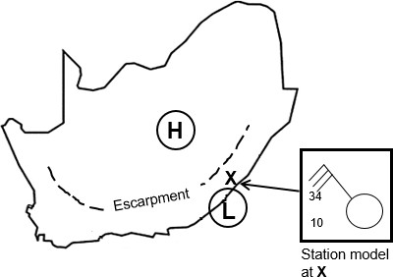
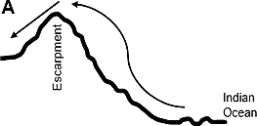 | 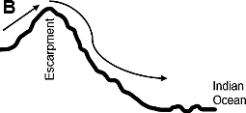
[Source: Examiner's own sketch]
    - Name the high-pressure cell and low-pressure cell indicated on the
sketch map that leads to the development of berg winds. (2 x 1) (2)
    - Which sketch (A or B) represents the formation of berg winds?(1 x 1) (1)
    - Give a reason for your answer to QUESTION 1.5.2. (1 x 2) (2)
    - Explain why cloudless conditions are indicated by the station model
at X on the sketch map. (1 x 2) (2)
    - In a paragraph of approximately EIGHT lines, explain how berg winds impact negatively on the natural vegetation and suggest strategies
that can be put in place to limit this negative impact. (4 x 2) (8)
[60]

QUESTION 2: GEOMORPHOLOGY
2.1 | Match the concepts below with the letters in the diagram. Write only the letter (A–H) next to the question numbers (2.1.1 to 2.1.8) in the ANSWER BOOK,  e.g. 2.1.9 K.
 | 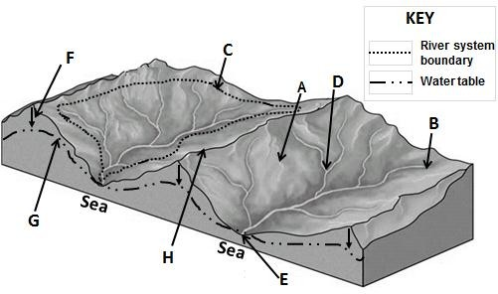
 |  | [Adapted from https://worldrivers.net/2020/03/25/drainage-basins/ | ]
 | 2.1.1 | Source of the river
 | 2.1.2 | The water table
 | 2.1.3 | An interfluve
 | 2.1.4 | A drainage basin
 | 2.1.5 | The river mouth
 | 2.1.6 | The watershed
 | 2.1.7 | A confluence
 | 2.1.8 | Process of infiltration (8 x 1) | (8)

2.2 | Various options are provided as possible answers to the following questions. Choose the answer and write only the letter (A–D) next to the question numbers (2.2.1 to 2.2.7) in the ANSWER BOOK, e.g. 2.2.8 D.  Refer to the sketch below on fluvial processes to answer QUESTIONS 2.2.1 to 2.2.4.
 | 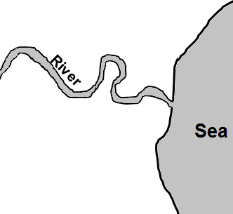
 |  |  | [Source: Examiner's own sketch]
 | 2.2.1 | The sketch illustrates a/an … of a river.
 |  | A | longitudinal profile
 |  | B | plan view
 |  | C | oblique view
 |  | D | cross-profile
 | 2.2.2 | The fluvial landform/feature shown in the sketch is a ...
 |  | A | delta.
 |  | B | waterfall.
 |  | C | meander.
 |  | D | rapid.
 | 2.2.3 | This fluvial landform/feature (answer to QUESTION 2.2.2) occurs mainly in the … course of a river.
 |  | A | middle
 |  | B | upper
 |  | C | lower
 |  | D | youth

2.2.4 | The dominant geomorphological process taking place in the course of the river (answer to QUESTION 2.2.3) is …
 | A | deposition.
 | B | erosion.
 | C | weathering.
 | D | grading.
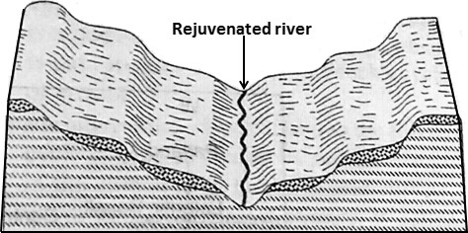
Refer to the sketch below showing river rejuvenation to answer QUESTIONS 2.2.5 to 2.2.7.

Rejuvenated river
KEY
Hard rock  Soft rock 
 |  | [Adapted from www.geologycafe.com]
2.2.5 | The cause for river rejuvenation as shown in the sketch is …
 | A | a rise in sea level.
 | B | a decreased volume of water.
 | C | a drop in the sea level.
 | D | headward erosion.
2.2.6 | The landforms/features visible in the sketch due to rejuvenation is/are …
 | (i) | interlocking spurs.
 | (ii) | a valley within a valley.
 | (iii) | paired terraces.
 | (iv) | incised meanders.
 | A | (i) and (iii)
 | B | (i) and (iv)
 | C | (ii) and (iii)
 | D | (ii) and (iv)

 | 2.2.7 | The longitudinal profile of the river after river rejuvenation would be …
 | 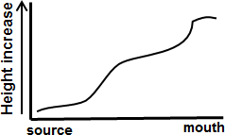  A | B  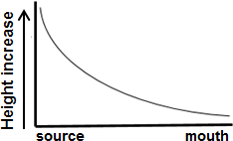
 | 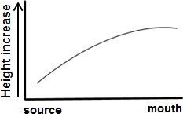  C | D  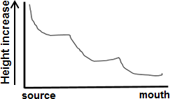
 |  | [Source: Examiner's own sketch]
 |  | (7 x 1) | (7)
2.3 | 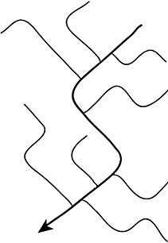  Refer to the drainage patterns illustrated in sketches A and B below.
A B
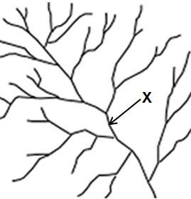
[Adapted from https://www.google.com/search?+drainage+pattern&tbm]
 | 2.3.1 | Identify drainage patterns in sketches A and B. (2 x 1) | (2)
 | 2.3.2 | State the underlying rock structure and rock type on which the drainage pattern in A developed. (1 + 1)
 |  |  | (2)
 | 2.3.3 | Explain how the underlying rock structure influenced the drainage pattern in A. (1 x 2)
 |  |  | (2)
 | 2.3.4 | The drainage density in B is (high/low). (1 x 1) | (1)
 | 2.3.5 | Determine the stream order at X. (1 x 2) | (2)
 | 2.3.6 | Explain the relationship between stream order and drainage density in B. (1 x 2)
 |  |  | (2)
 | 2.3.7 | Explain how the slope (gradient) and permeability of underlying rock influence the drainage density in B. (2 x 2)
 |  |  | (4)

2.4 | Refer to the sketches below on river capture (stream piracy).
 | 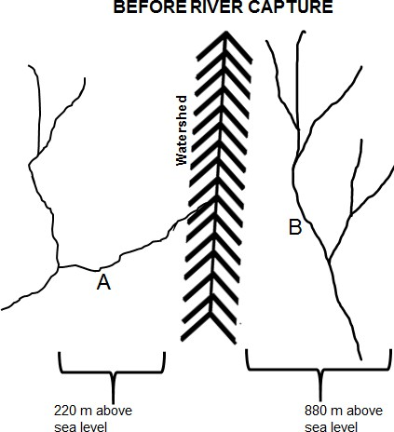
 | 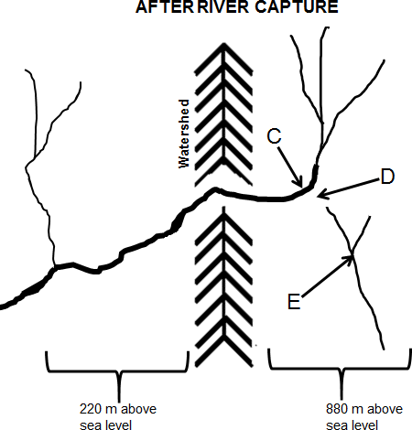
 |  | [Source: Examiner's own sketches]
 | 2.4.1 | Which river (A or B) has more erosive power? (1 x 1) | (1)
 | 2.4.2 | Give ONE reason evident in the sketches to support your answer to QUESTION 2.4.1. (1 x 2)
 |  |  | (2)
 | 2.4.3 | Identify features C and D. (2 x 1) | (2)
 | 2.4.4 | Give ONE characteristic of feature D. (1 x 2) | (2)
 | 2.4.5 | In a paragraph of approximately EIGHT lines, describe the changes that river E will experience after river capture has taken place. (4 x 2)
 |  |  | (8)

2.5 | Refer to the extract below on catchment and river management.
ALIEN PLANTS ARE THE GREATEST THREAT TO CAPE TOWN'S WATER SECURITY
Alien plants* are possibly the greatest threat to Cape Town's water security. The roots of plants absorb groundwater. The current water loss due to alien plants is more than 100 million litres which is nearly 20% of what Capetonians are currently using daily.
To address water security, the city of Cape Town plans to extract water from aquifers** in addition to existing dams. However, the plan to extract groundwater is experiencing challenges due to alien trees absorbing groundwater in the mountain catchment areas. Extracting groundwater (by drilling boreholes into aquifers) to add to the existing water supply, without addressing the clearing of alien plans, will cause a bigger water supply problem in future.
Catchment restoration (repair) is the solution to water security, and alien clearing programmes are key to this restoration. However, underfunding and inefficiencies are hampering the implementation of alien clearing programmes in the catchment areas.
Restoring and maintaining our catchments in a healthy state are essential (important) for water security in Cape Town and the surrounding region. The threat of alien plants to water security will not go away and will only become a greater problem the longer it is not properly addressed.
Glossary:
*alien plants: plants from another country
**aquifers: water-bearing rocks
[Adapted from https://www.groundup.org.za/author/]
 | 2.5.1 | How much water is lost due to alien plants, according to the extract?  (1 x 1)
 |  |  | (1)
 | 2.5.2 | Give TWO plans in the extract that the Cape Town municipality intends to use to improve water security. (2 x 1)
 |  |  | (2)
 | 2.5.3 | According to the extract, what are the challenges that are faced when implementing these plans (answer to QUESTION 2.5.2)?  (2 x 2)
 |  |  | (4)
 | 2.5.4 | Describe the positive impact of the removal of alien plants on the:
 |  | (a) Volume of water in the dam (1 x 2) | (2)
 |  | (b) Water table (1 x 2) | (2)
 | 2.5.5 | Why will the removal of alien plants improve the biodiversity of the catchment area? (2 x 2)
 |  |  | (4)
 |  |  | [60]
 |  | TOTAL SECTION A: | 120

SECTION B

QUESTION 3: GEOGRAPHICAL SKILLS AND TECHNIQUES

GENERAL INFORMATION ON QUEENSTOWN

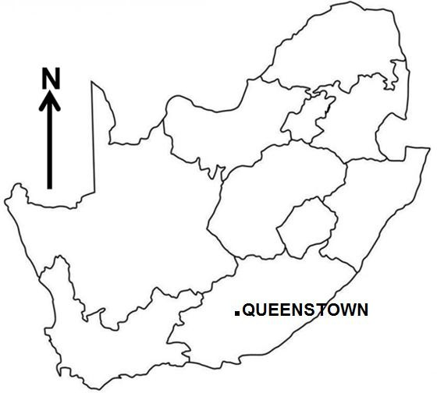
Coordinates: 31°54'S; 26°53'E

Queenstown (officially known as Komani) is a town in the Eastern Cape in South Africa. The town lies on the banks of the Komani River which forms part of the Great Kei river system and has a refreshing climate and an abundant water supply from the surrounding rugged mountains.

The area's annual average temperature is 18,29 °C which is 2,93% lower than the average for South Africa. Queenstown generally receives approximately 90,83 millimetres of precipitation and has 134 rainy days annually.

Winters are short, cold, dry and windy; it is mostly clear year-round.

[Adapted from https://en.wikipedia.org/wiki/Queenstown]
The following English terms and their Afrikaans translations are shown on the topographical map:

ENGLISH AFRIKAANS
Diggings Uitgrawings
River Rivier

3.1 | MAP SKILLS AND CALCULATIONS
 | 3.1.1 | Which human-made feature is found at grid reference 31°49'41"S; 26°45'35"E on the topographical map?
 |  | A | Trees
 |  | B | Spot height
 |  | C | Ruin
 |  | D | Building (1 x 1) | (1)
 | 3.1.2 | The contour interval on the orthophoto map is … metres.
 |  | A | 5
 |  | B | 10
 |  | C | 15
 |  | D | 20 (1 x 1) | (1)
 | 3.1.3 | The photo number for the orthophoto map of NOOITGEDACHT is …
 |  | A | 31
 |  | B | 26
 |  | C | DD
 |  | D | 1 (1 x 1) | (1)
 | 3.1.4 | Calculate the area in m² of the farm labelled F in block E3 on the topographical map. Use the following measurements if the length on the map is 0,9 cm and the breadth on the map is 0,7 cm.  Formula: Length x Breadth (3 x 1)
 |  |  |  | (3)
 | 3.1.5 | Calculate the average gradient from 6 in block D4 to 7 in spot height 1567 in block D2 if the horizontal equivalent (HE) is 950 m on the orthophoto map.  Formula: Vertical Interval (VI)  Horizontal Equivalent (HE) (3 x 1)
 |  |  |  | (3)
 | 3.1.6 | There is no intervisibility between 8 in block D4 and 9 in block D2 on the orthophoto map. Name the type of slope responsible for this.  (1 x 1)
 |  |  |  | (1)

  - MAP INTERPRETATION

    - Map evidence indicates … rainfall because of the … blue lines on the topographical map.

(i)  (ii)  (iii)  (iv) | annual seasonal continuous dashed
A | (i) and (iii)
B | (i) and (iv)
C | (ii) and (iii)
D | (ii) and (iv) | (1 x 1) | (1)

Refer to the encircled area G in block B1 on the topographical map.

    - Explain how the katabatic wind influences the temperatures at G in
block B1 on the topographical map. (1 x 2) (2)
The table below shows crops and the temperatures at which these crops are likely to survive.

CROPS | PUMPKIN | TOMATOES
Average  temperature | -2 °C | 5 °C
    - Which crop (pumpkin or tomatoes) is most likely found at G in
block B1 on the topographical map? (1 x 1) (1)

    - Give a climatological reason for your choice (answer to QUESTION 3.2.3). (1 x 2) (2)

Refer to the river at 10 on the orthophoto map.

    - The river at 10 on the orthophoto map generally flows in a
(south-westerly/north-easterly) direction. (1 x 1) (1)

    - Give a reason for your answer to QUESTION 3.2.5. (1 x 2) (2) Refer to the river at H on the topographical map.
    - In which stage, (upper course/middle course), is the river at H in
block B5 on the topographical map? (1 x 1) (1)

    - Give evidence from the topographical map to support your answer to QUESTION 3.2.7. (1 x 2) (2)

3.3 | GEOGRAPHICAL INFORMATION SYSTEMS (GIS)
 | 3.3.1 | The environmental issue labelled I in block A2 is represented as a … feature on the topographical map.
 |  | A | point
 |  | B | polygon
 |  | C | node
 |  | D | line (1 x 1) | (1)
 | 3.3.2 | Remote sensing is defined as taking images of the Earth's surfaces from a distance.  Explain how remote sensing can be used to effectively monitor the environmental issue mentioned in QUESTION 3.3.1. (1 x 2)
 |  |  |  | (2)

The municipality provides a GIS specialist with the topographical map and orthophoto map to check the availability of water at dam J (topographical map) and 11 (orthophoto map).
3.3.3 | Define the concept raster data. (1 x 2) | (2)
3.3.4 | A (topographical map/orthophoto map) is a representation of raster data. (1 x 1)
 |  | (1)
3.3.5 | Why is the information on the orthophoto map more realistic when determining the availability of water in the dam at a specific time?  (1 x 2)
 |  | (2)
 | TOTAL SECTION B: | 30
 | GRAND TOTAL: | 150

